IR Sensor Project

Bryce Leeper

09/27/22

The range is approximately 10cm – 80 cm. It also tends to not be as accurate towards the ends. The Infrared Sensor can detect if something is in front of it in a certain distance.

Code:

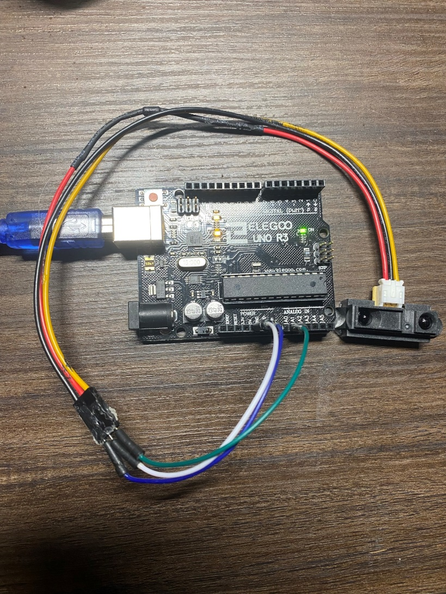/*SHARP GP2Y0A21YK0F IR distance sensor with Arduino and SharpIR library example code. More info: https://www.makerguides.com */

// Include the library:

#include <SharpIR.h>

// Define model and input pin:

#define IRPin A0

#define model 1080

// Create variable to store the distance:

int distance_cm;

/* Model :

GP2Y0A02YK0F --> 20150

GP2Y0A21YK0F --> 1080

GP2Y0A710K0F --> 100500

GP2YA41SK0F --> 430

*/

// Create a new instance of the SharpIR class:

SharpIR mySensor = SharpIR(IRPin, model);

void setup() {

// Begin serial communication at a baudrate of 9600:

Serial.begin(9600);

}

void loop() {

// Get a distance measurement and store it as distance_cm:

distance_cm = mySensor.distance();

// Print the measured distance to the serial monitor:

Serial.print("Mean distance: ");

Serial.print(distance_cm);

Serial.println(" cm");

delay(1000);

}

There are several things that I want to measure. One of the things is that can be focused on is range, measuring tape with a platform can be used for that. If it can be figured out, then I would also like to test for resolution, accuracy, and precision.